i need to start mapping out trainings by analuyzing conversation of what i am asked to start doing for providing a central area for training and fill in the table on the slide in the image accordingly
access training links started and seen in image to fill in table here
https://www.center-of-excellence.xyz/training
also more training content:
AI Hack Pro Tip TL;DR: Free tool that transforms lazy prompts into effective ones → https://www.promptcowboy.ai/ How it works:
- Input your existing prompt (or write a new one)
- Select your model type:
  - Standard models (e.g., Gemini 2.5 flash)
  - Deep research/reasoning models
- Get an optimized prompt tailored to your chosen model
Example: Working on a sales task with Gemini Deep Research? Run your basic sales research prompt through the optimizer to get a version that leverages the model’s full capabilities. Why use it: Different AI models respond better to different prompting styles. This tool ensures you’re speaking each model’s “language” for maximum output quality.
claude skills explained:
https://www.youtube.com/watch?v=MZZCW179nKM&amp;t=1421s
Today I dive into Anthropic’s latest feature that lets anyone create reusable workflows for Claude—no coding required. I break down exactly what Claude Skills are, how to build them from scratch, and how to use them inside Claude Code and Cursor to automate recurring AI tasks like generating PRDs, writing changelog summaries, and turning demo notes into follow-up emails.

What you’ll learn:
1. What Claude Skills are and how they differ from Claude Projects and custom GPTs
2. How to structure a Skill (metadata, instructions, and linked files)
3. Why defining workflows in natural language beats rigid automation tools
4. How to create Claude Skills using Claude Code and Cursor
5. How to validate your skills with Python scripts and folder references
6. How to upload and use Claude Skills inside Claude’s web or desktop app
7. Practical examples: turning changelogs into newsletters, demo notes into emails, and more
https://www.producttalk.org/claude-code-what-it-is-and-how-its-different/
Why is everyone talking about Claude Code?I'm seeing it pop up everywhere—in my LinkedIn feed, on product podcasts, and in my Slack communities. And it's not just developers talking about it. It's product managers, writers, researchers, consultants, you name it.And I get it. I love Claude Code.
https://www.producttalk.org/give-claude-code-a-memory/
"Can you critique the landing page for my new Story-Based Customer Interviews course?"I used to waste hours trying to get ChatGPT or Claude to adequately critique my work. I'd get frustrated by the generic feedback, the poor writing, and the suggestions that just wouldn't work for my
tips tricks tricks for claude code from the guy who built it
(see pasted content)
AI Voice Note iOS Shortcut so i record a lot of voice memos and then copy and paste the transcription into AI, ask it to summarize, and then save that somewhere. it's a pain in the ass. this shortcut fixes that. just speak, Whisper transcribes, Claude summarizes, and it auto-saves the output to Apple Notes. i trigger it from my lock screen with back tap so i don't have to unlock. shortcut link What you need
- OpenAI API key for Whisper (platform.openai.com)
- Anthropic API key for Claude (console.anthropic.com)
- a folder in Apple Notes called "Voice Notes"
both are pay-per-use a note costs about $0.01
Setup
- tap the link, add the shortcut
- paste your OpenAI key in the first text block
- paste your Anthropic key in the second text block
- create the "voice notes" folder in apple notes
Trigger using the action button settings → action button → shortcuts → select the shortcut
one thing that's been pretty valuable is, on my way to work each day, i'll review my calendar and record a voice note while I'm doing it, saying things like what i need to do to prep/reschedule/etc. out loud. it then takes that and outputs a plan for how i can prepare for my day.
andy.damato [10:16 AM]
Love this. Is there a Gemini / iPhone (free) version of this @Austin?
Austin [3:08 PM]
unsure! let me check and get back to you.
Nate Larkin [4:29 PM]
@andy.damato - here is a free app without the setup of above: https://apps.apple.com/us/app/superwhisper/id6471464415
App Store
superwhisper App - App Store
Download superwhisper by SuperUltra, Inc. on the App Store. See screenshots, ratings and reviews, user tips, and more games like superwhisper.
https://apps.apple.com/us/app/superwhisper/id6471464415
[4:33 PM]
You can also just take a voice note, it auto transcribes. Copy and paste into gemini app. My protip on this is start by saying...
"I am going to just talk, I want you to take these thoughts and structure them in the right format based on what I say"
Claude Agent SDK full workshop
https://www.youtube.com/watch?v=TqC1qOfiVcQ
agent skills directory
https://skills.sh/trending
https://agentation.dev/features
TLDR: When you run a local preview you can use this tool to annotate changes:
- Add more padding here
- Change this button to follow the gladly green style
- etc.
Then it will kick out a .md will all the context of the changes.. Where previously you might have screenshotted with an annotation ontop or just gave it instructions to move a button to center align and it is hit or miss and creates that annoying wrestling with claude to get the ui changes you want
Quick tip: You can open the Claude Code Desktop input field by clicking the Option ⌥ key twice or clicking the Claude Icon on the desktop header!
https://vercel.com/go/shipping-gtm-workflows-using-v0-pipeline
Claude Desktop App Overview
https://www.loom.com/share/97cb836202304912a45df619caa22f08
quick overview of the Claude desktop app and its features.

It covers how to navigate between Chat, Cowork, and Code, plus some tips on how to get the most out of it.

Check it out when you have a moment! (edited)

Protip, make sure that you are always updating Claude desktop when new versions come out, this is a 2 week old product that was built in 10 days... They are shipping new features fast and early versions are super buggy

3 replies
Austin [2:15 PM]
what's the best way to do this nate?

mh [2:18 PM]
just restart the desktop app. there's also a button in the main menu for it -

Screenshot 2026-01-28 at 11.17.42 AM.png
[2:18 PM]
case in point is that I updated earlier this morning, and there's already a new version 
You can leverage agent swarms before its released using the compound engineering plugin -
https://github.com/EveryInc/compound-engineering-plugin (if you are building anything you should be using this plugin - but if you wanna use agent swarm its /orchestrating-swarms
https://gist.github.com/kieranklaassen/4f2aba89594a4aea4ad64d753984b2ea
https://anthropic.skilljar.com/claude-code-in-action
Claude Code in Action
Practical walkthrough of using Claude Code to accelerate your development workflow
Enroll in CourseFREE
Already registered? Sign In
Share on XShare on LinkedIn
15lectures
1hour of video
1quiz
✓Certificate of completion
About this course
This course covers Claude Code, a command-line AI assistant that uses language models to perform development tasks. You'll learn how Claude Code reads files, executes commands, and modifies code through its tool system, along with techniques for managing context, creating custom workflows, extending Claude Code with hooks, and integrating with external services.
Learning objectives
By the end of this course, you'll be able to:
- Use Claude Code's core tools for file manipulation, command execution, and code analysis
- Manage context effectively using /init, Claude.md files, and @ mentions
- Control conversation flow with a variety of hotkeys and commands
- Enable Plan Mode and Thinking Mode for complex tasks requiring deeper analysis
- Create custom commands for automating repetitive development workflows
- Extend Claude Code with MCP servers to add browser automation and other capabilities
- Set up GitHub integration for automated PR reviews and issue handling
- Write hooks to add additional behavior into Claude Code
Prerequisites
- Basic familiarity with command line interfaces
- Access to Claude Code and an API key
Who this course is for
Engineers who want to speed up their development workflow with AI assistance

https://www.youtube.com/watch?v=r8jQ9hVA2qs
Skip navigation
Create
A brief introduction to Git for beginners | GitHub
GitHub
590K subscribers
Subscribe
15K
Share
Ask
Save
Download
817,674 views May 26, 2024 #Git #Coding #GitHub
Learn the fundamentals of Git, including installation, configuration, and essential concepts like staging, committing, and branching. By the end of this video, you'll have a solid foundation in Git and be ready to use it in your projects. Welcome to the GitHub for Beginners video series! In this comprehensive tutorial, join GitHub Developer Advocate Kedasha Kerr as she guides you through everything you need to know to get started and be successful with Git and GitHub.

Making Playgrounds using Claude Code
We've published a new Claude Code plugin called playground that helps Claude generate HTML playgrounds. These are standalone HTML files that let you visualize a problem with Claude, interact with it and give you an output prompt to paste back into Claude Code.
I've found this can be really good interacting with the model in ways that are not well suited for text, for example to:
- Visualize the architecture of the codebase
- Adjust the design of a component
- Brainstorm layouting and design
- Tweak the balance of a game
To get started, install the plugin in Claude code by running the following commands:
/plugin marketplace update claude-plugins-official
/plugin install playground@claude-plugins-official

Here are some of my favorite playgrounds I've made:

Changing the design of the AskUserQuestion Tool in Claude Code
prompt: "Use the playground skill to create an playground that helps me explore new layout changes to the AskUserQuestion Tool"
0:02 / 0:23

Critiquing your writing and getting a response
prompt: "Use the playground skill to review my SKILL.MD and give me inline suggestions I can approve, reject or comment"
0:00 / 0:32

Tweaking a Remotion Video Intro
prompt: "Use the playground skill to tweak my intro screen to be more interesting and delightful"
0:01 / 0:21
Viewing an Architecture Diagram and letting the user comment
prompt: "Use the playground skill to show how this email agent codebase works and let me comment on particular nodes in the architecture to ask questions, make edits, etc"
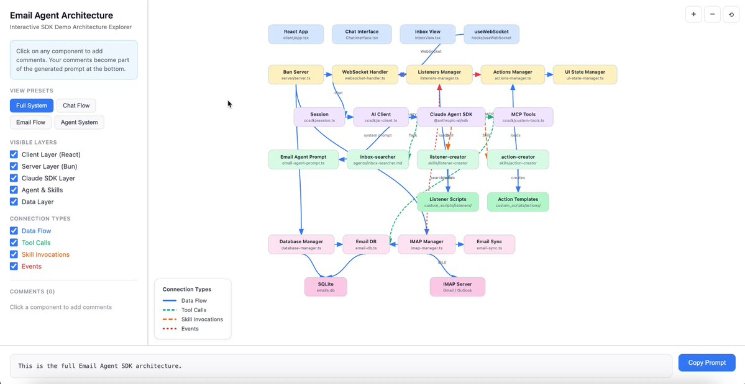
Balancing the Superhero Rogue-like game I'm making
prompt: "Use the playground skill to help me balance the 'Inferno' hero's deck"
Excited to see how you all explore this!

My tip for creating an interesting playground- think of a unique way of interacting with the model and then ask it to express that. I think you might find it surprising.

the majority of your time in a coding project with ai should be spent in planning mode.

it's the same way you would set someone on your team up for success. the majority of the time is spent aligning on what success looks like and setting expectations. AI agents are no different.

my planning process usually goes something like this:
- spend about 15-20 mins just word vomiting my idea at my computer (you can use an Apple Voice Memo for this)
- copy that transcript into Claude, and ask it to turn it into a SPEC.md file (a specification doc) to make your thoughts more coherent.
- take that doc and share it with Claude Code, put it in plan mode (cycle modes using shift + tab) and paste the following prompt (see Prompt for step 3 below).
- answer all the questions it asks. if i don't know what it's asking, or i want more detail regarding the tradeoffs it's proposing, i say so to Claude (there's usually an 'other' option where you can type your own response).
- once it's done asking questions it will present a plan to me to approve. I read this thoroughly and don't approve it until i am happy with every aspect of the plan!
  - Tip: if the plan is too technical, i tell it i need a non-technical version of the plan before i'm comfortable approving (ex. 'hey i'm non-technical, but want to be able to pick up what you're putting down...please update').
- approve the plan, sit back and relax, and click approve like a million times (sarcasm).

Prompt for step 3
read this @SPEC.md file and interview me in detail using the AskUserQuestionTool about literally anything: technical implementation, UI & UX, concerns, tradeoffs, etc. but make sure the questions are not obvious. be very in-depth and continue interviewing me continually until it's complete, then write the detailed spec to the file.

